SYSTEM DESIGN

1. ARCHITECTURE DIAGRAM

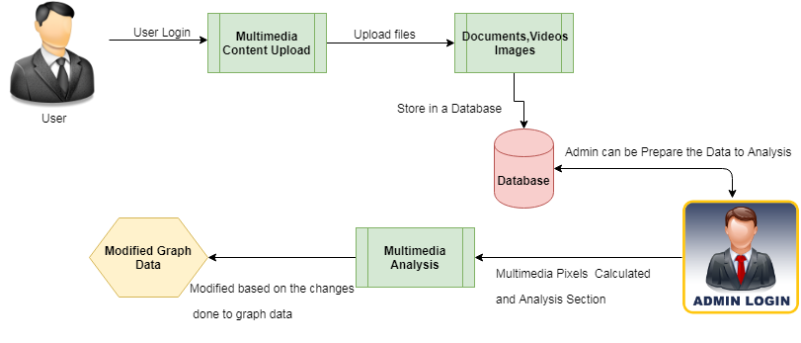

2. COMPONENT DIAGRAM

* 1. User

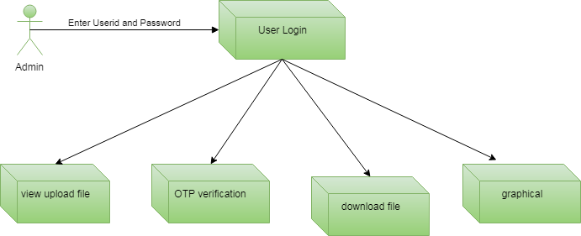

b. Admin

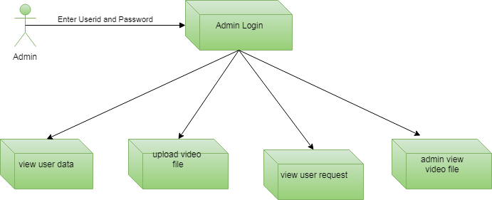

3. ER DIAGRAM

* 1. User

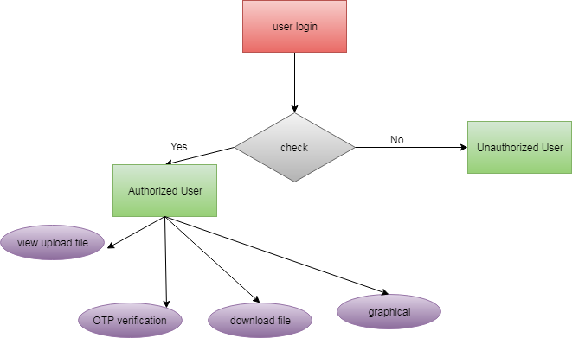

b. Admin

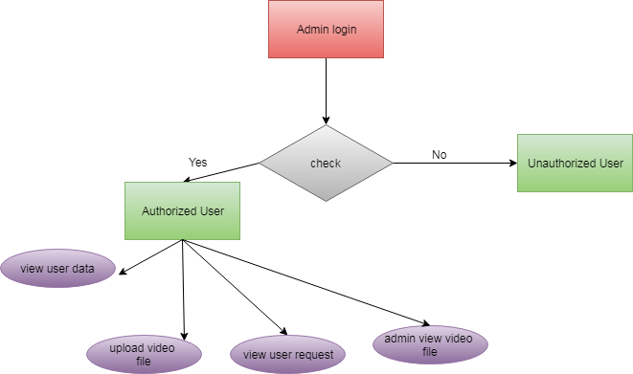

4. USE CASE DIAGRAM

* 1. User

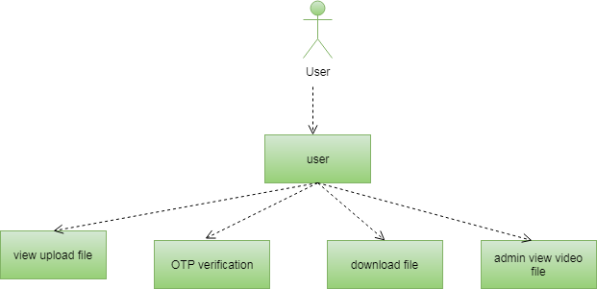

b. Admin

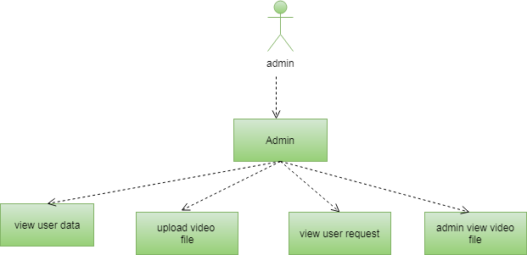

5. CLASS DIAGRAM

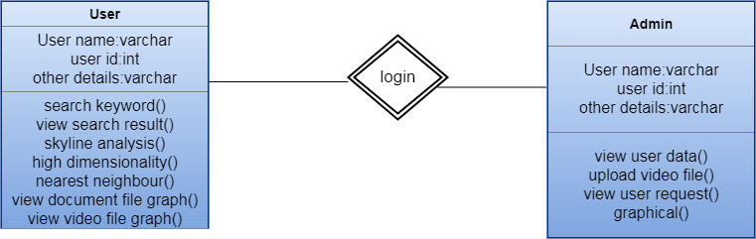

6. DATA FLOW DIAGRAM

* 1. User

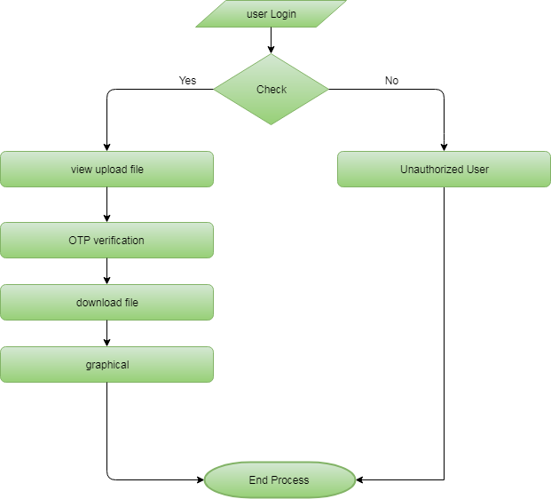

b. Admin

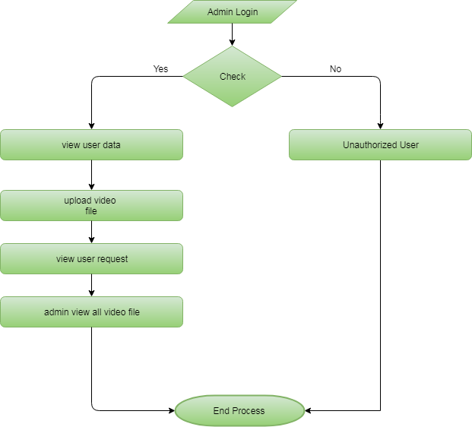

7. ACTIVITY DIAGRAM

* 1. User

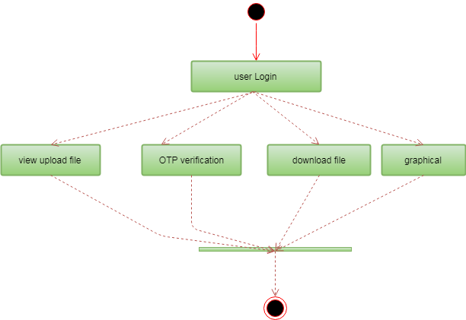

b.Admin

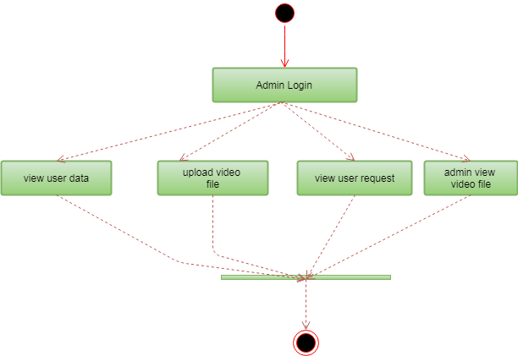

8.SEQUENCE DIAGRAM

* 1. User

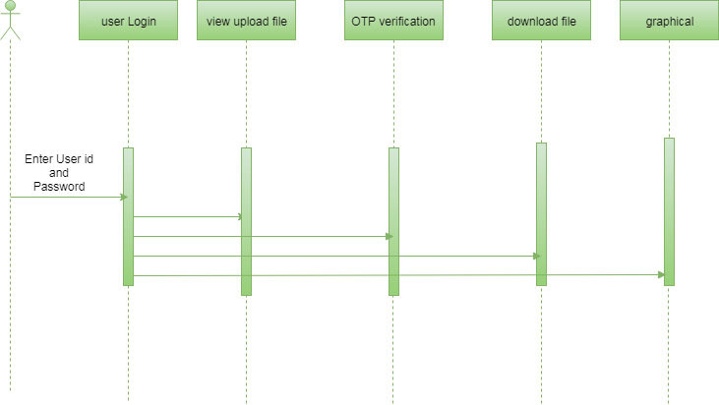

b.Admin

